**mindLAMP 2 Provider Instructions**

Providers will use LAMP as a way to track patient’s assessments and to complete clinician batteries. FEP client engagement forms need to be completed within 48 hours of a completed assessment. The assessment coordinator will notify the provider via email to inform the provider that this needs to be completed.

1. Logging onto mindLAMP 2. Use the following login information to log into [LAMP](https://dashboard.lamp.digital/#/researcher/me)-:

* **\*Domain Address:** lamp.mapnet.io (it is **CRITICAL** that you are using this server so data is captured in the correct place (picture below)
* **Username:** Your CHA email
* **Password:** Your unique password

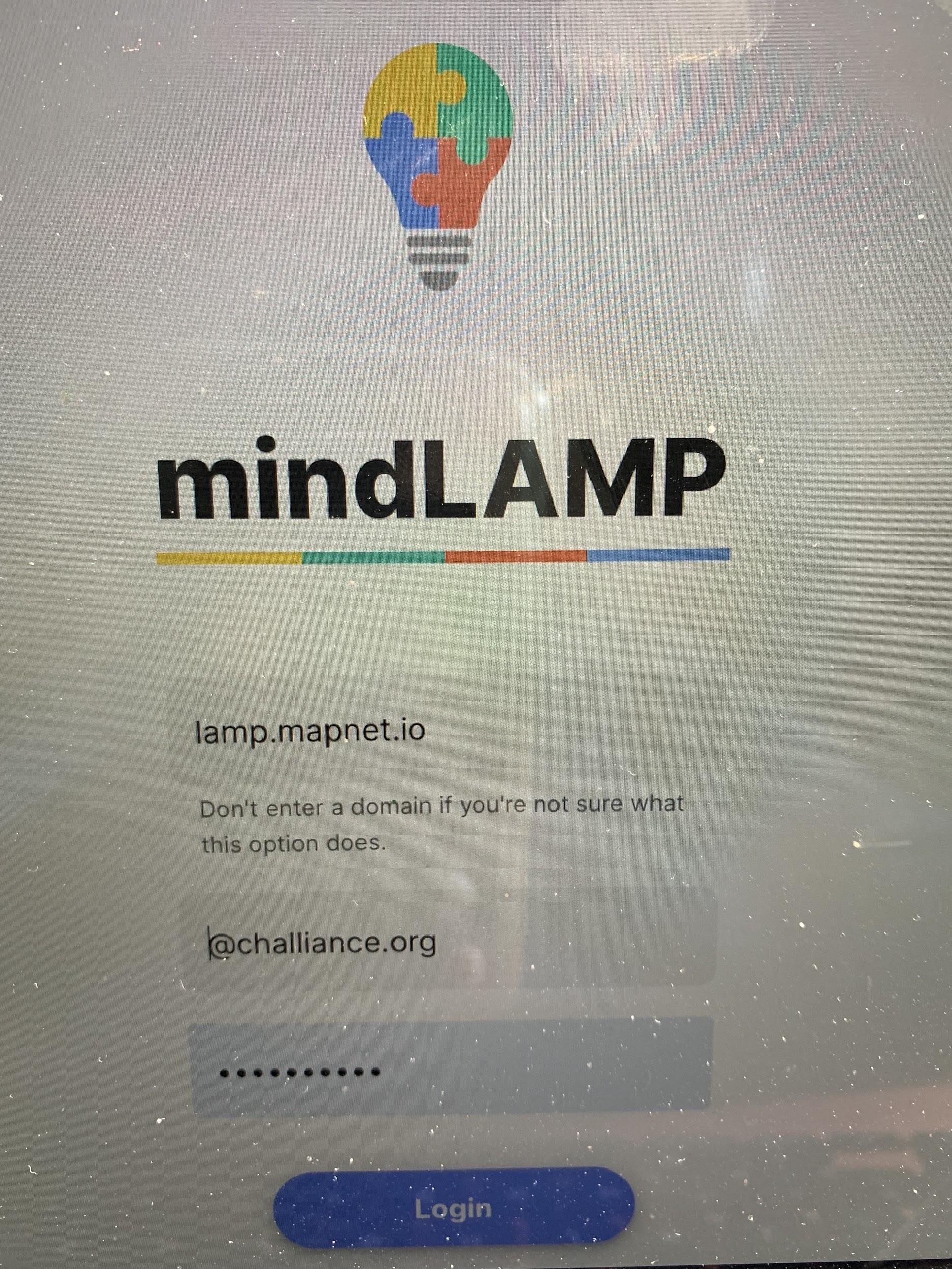

1. Once logged in, you will be automatically taken to the **“Patients”** page. Each patient can be identified by their four digit number that is also listed in the first column on the *Assessment Tracker* of the RISE roster in the Google RISE drive.

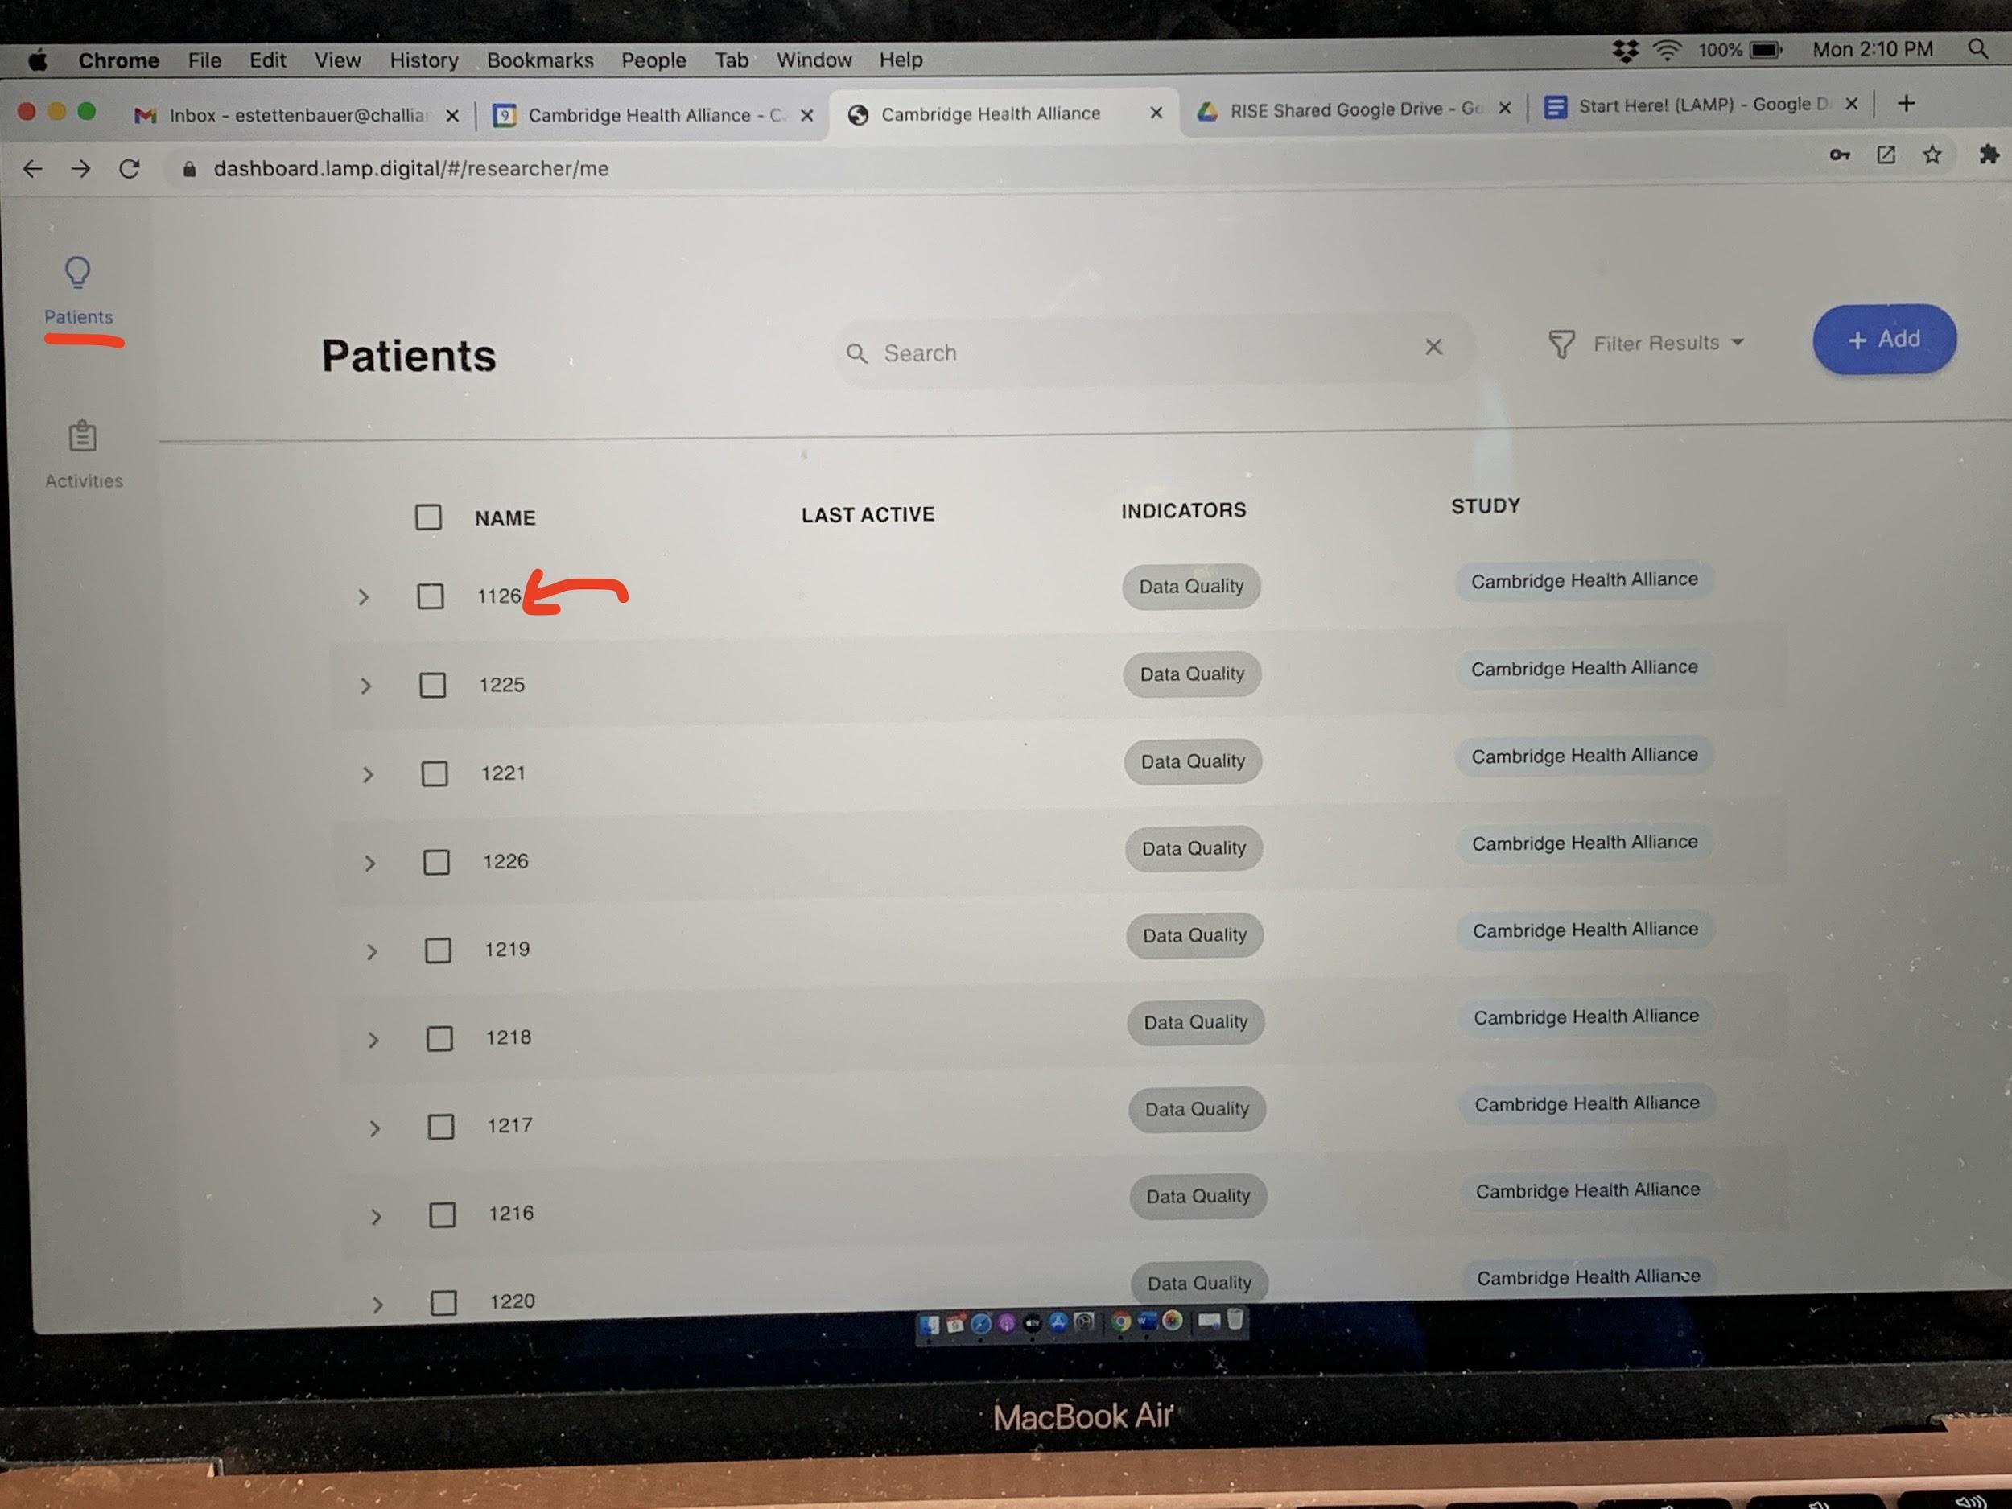

1. Find the patient you have been notified to do the two clinical scales of the assessment for and click on their deidentified number (in this example picture, the “1126”).

* This will take you to the **“Prevent”** tab.You will want to click on the “**Assess”** tab on the left sidebar (next page)

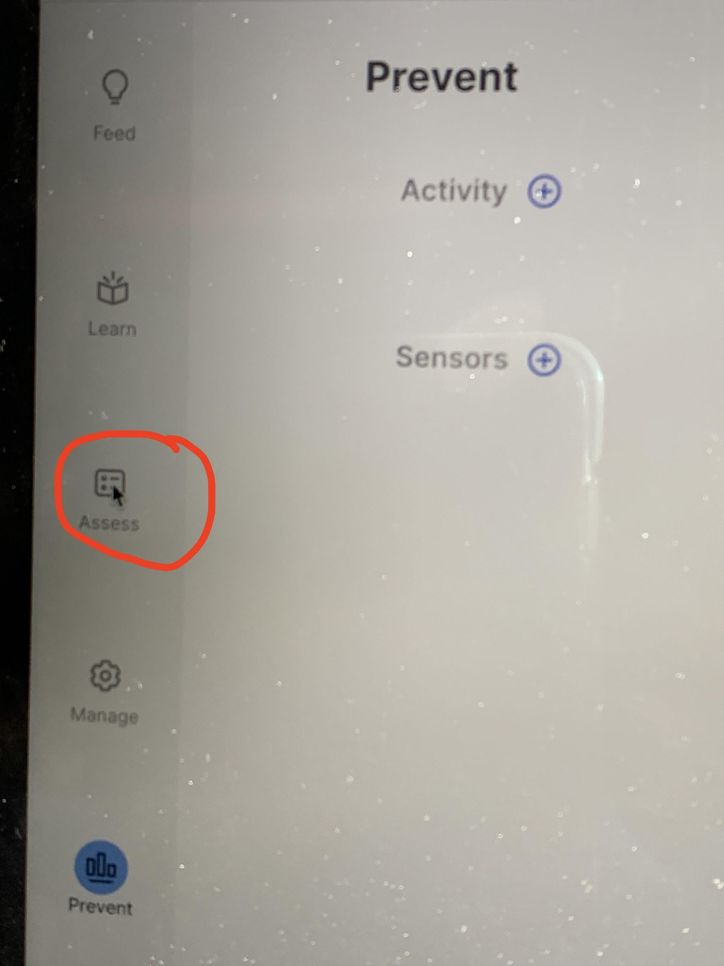

* It will bring you to a page of all assessments that exist for that patient

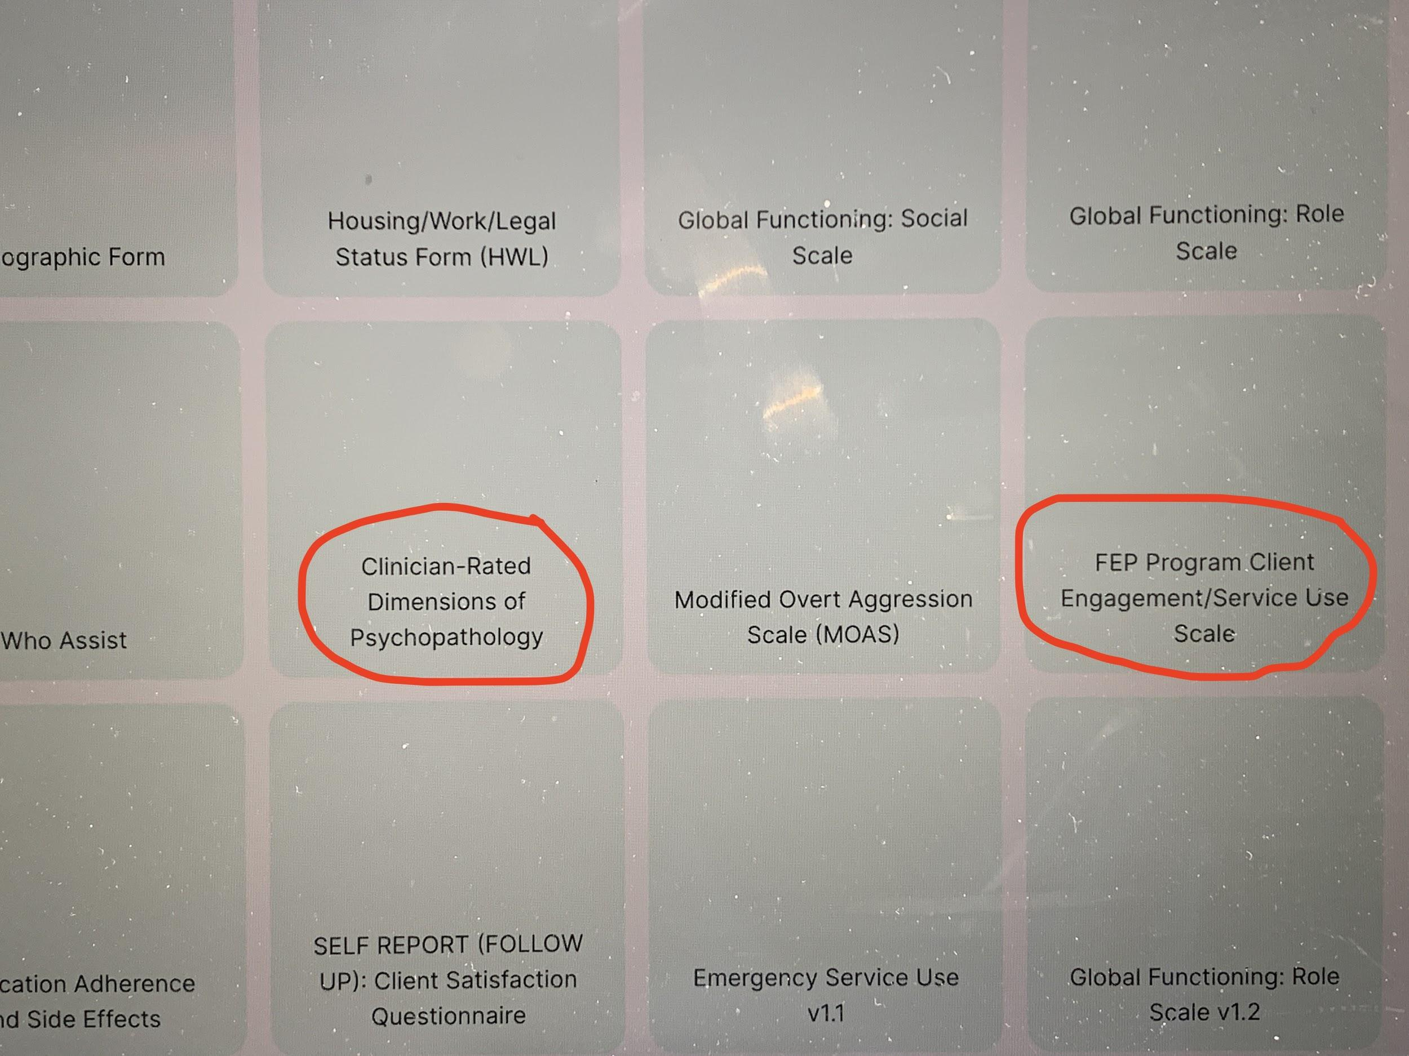

1. To complete the *FEP Program Client Engagement/Service Use Scale*

* Click on it (circled in red) and complete all responses thoroughly. When you are finished, click **“submit”** at the bottom of the page.

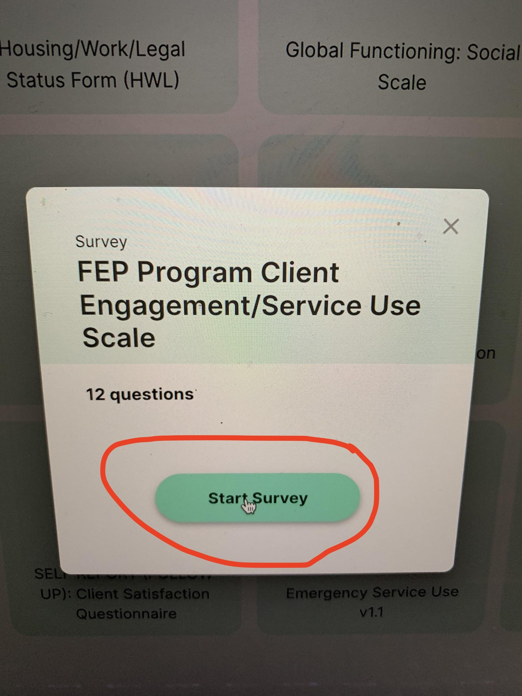

(next page)

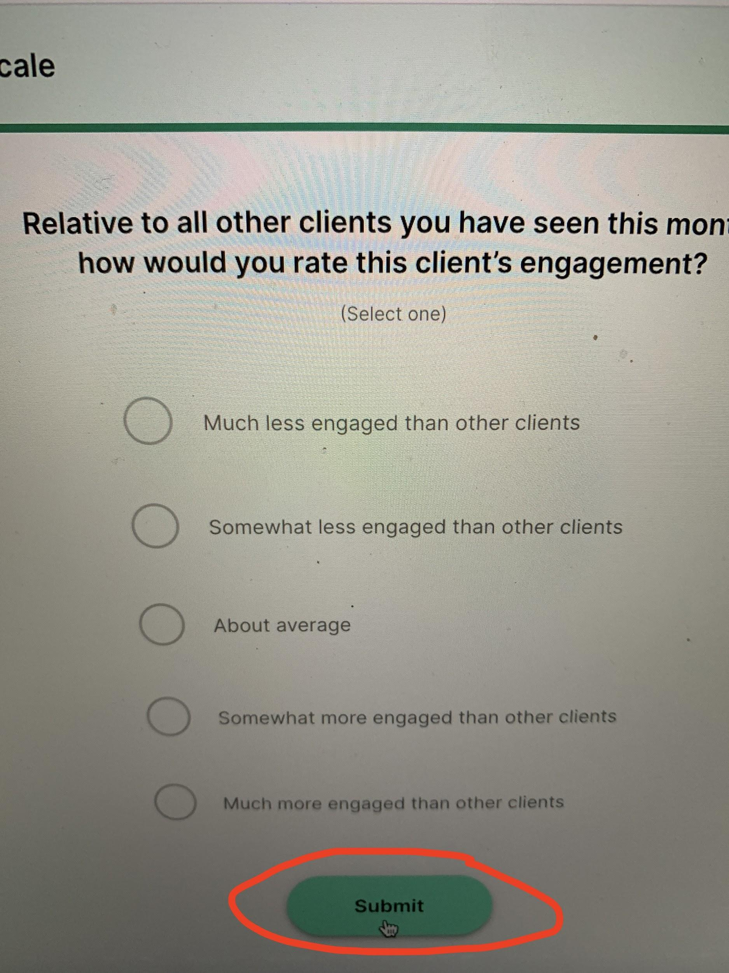

1. To complete the *Clinician-Rated Dimensions of Psychopathology* (next page)

* Click on it (circled in red) and complete all responses thoroughly. When you are finished, click **“submit”** at the bottom of the page.

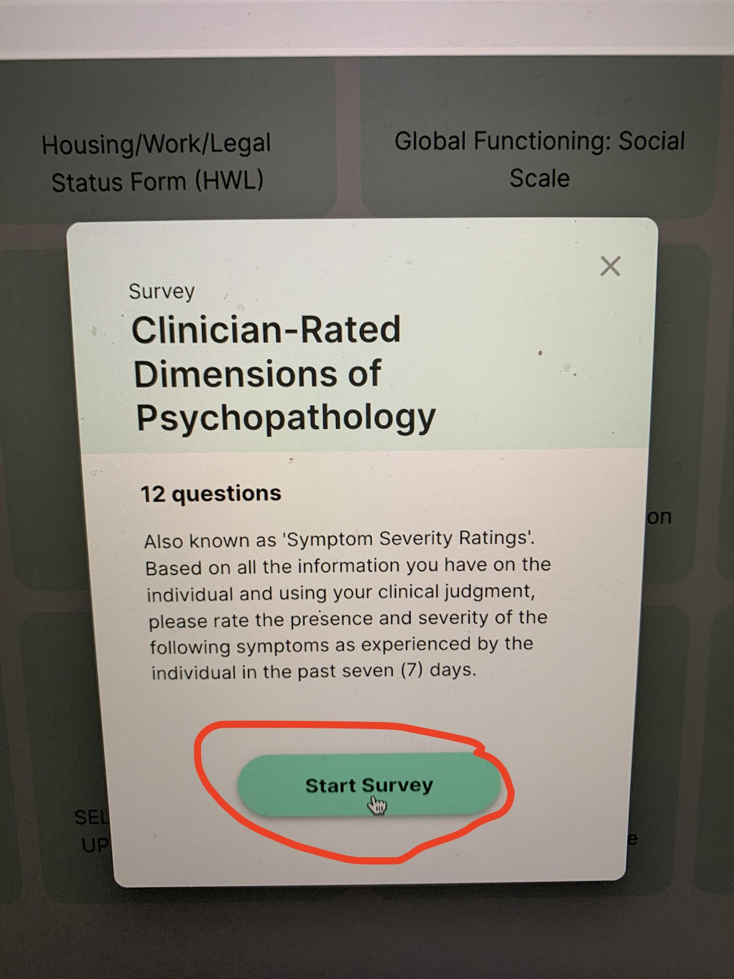 (next page)

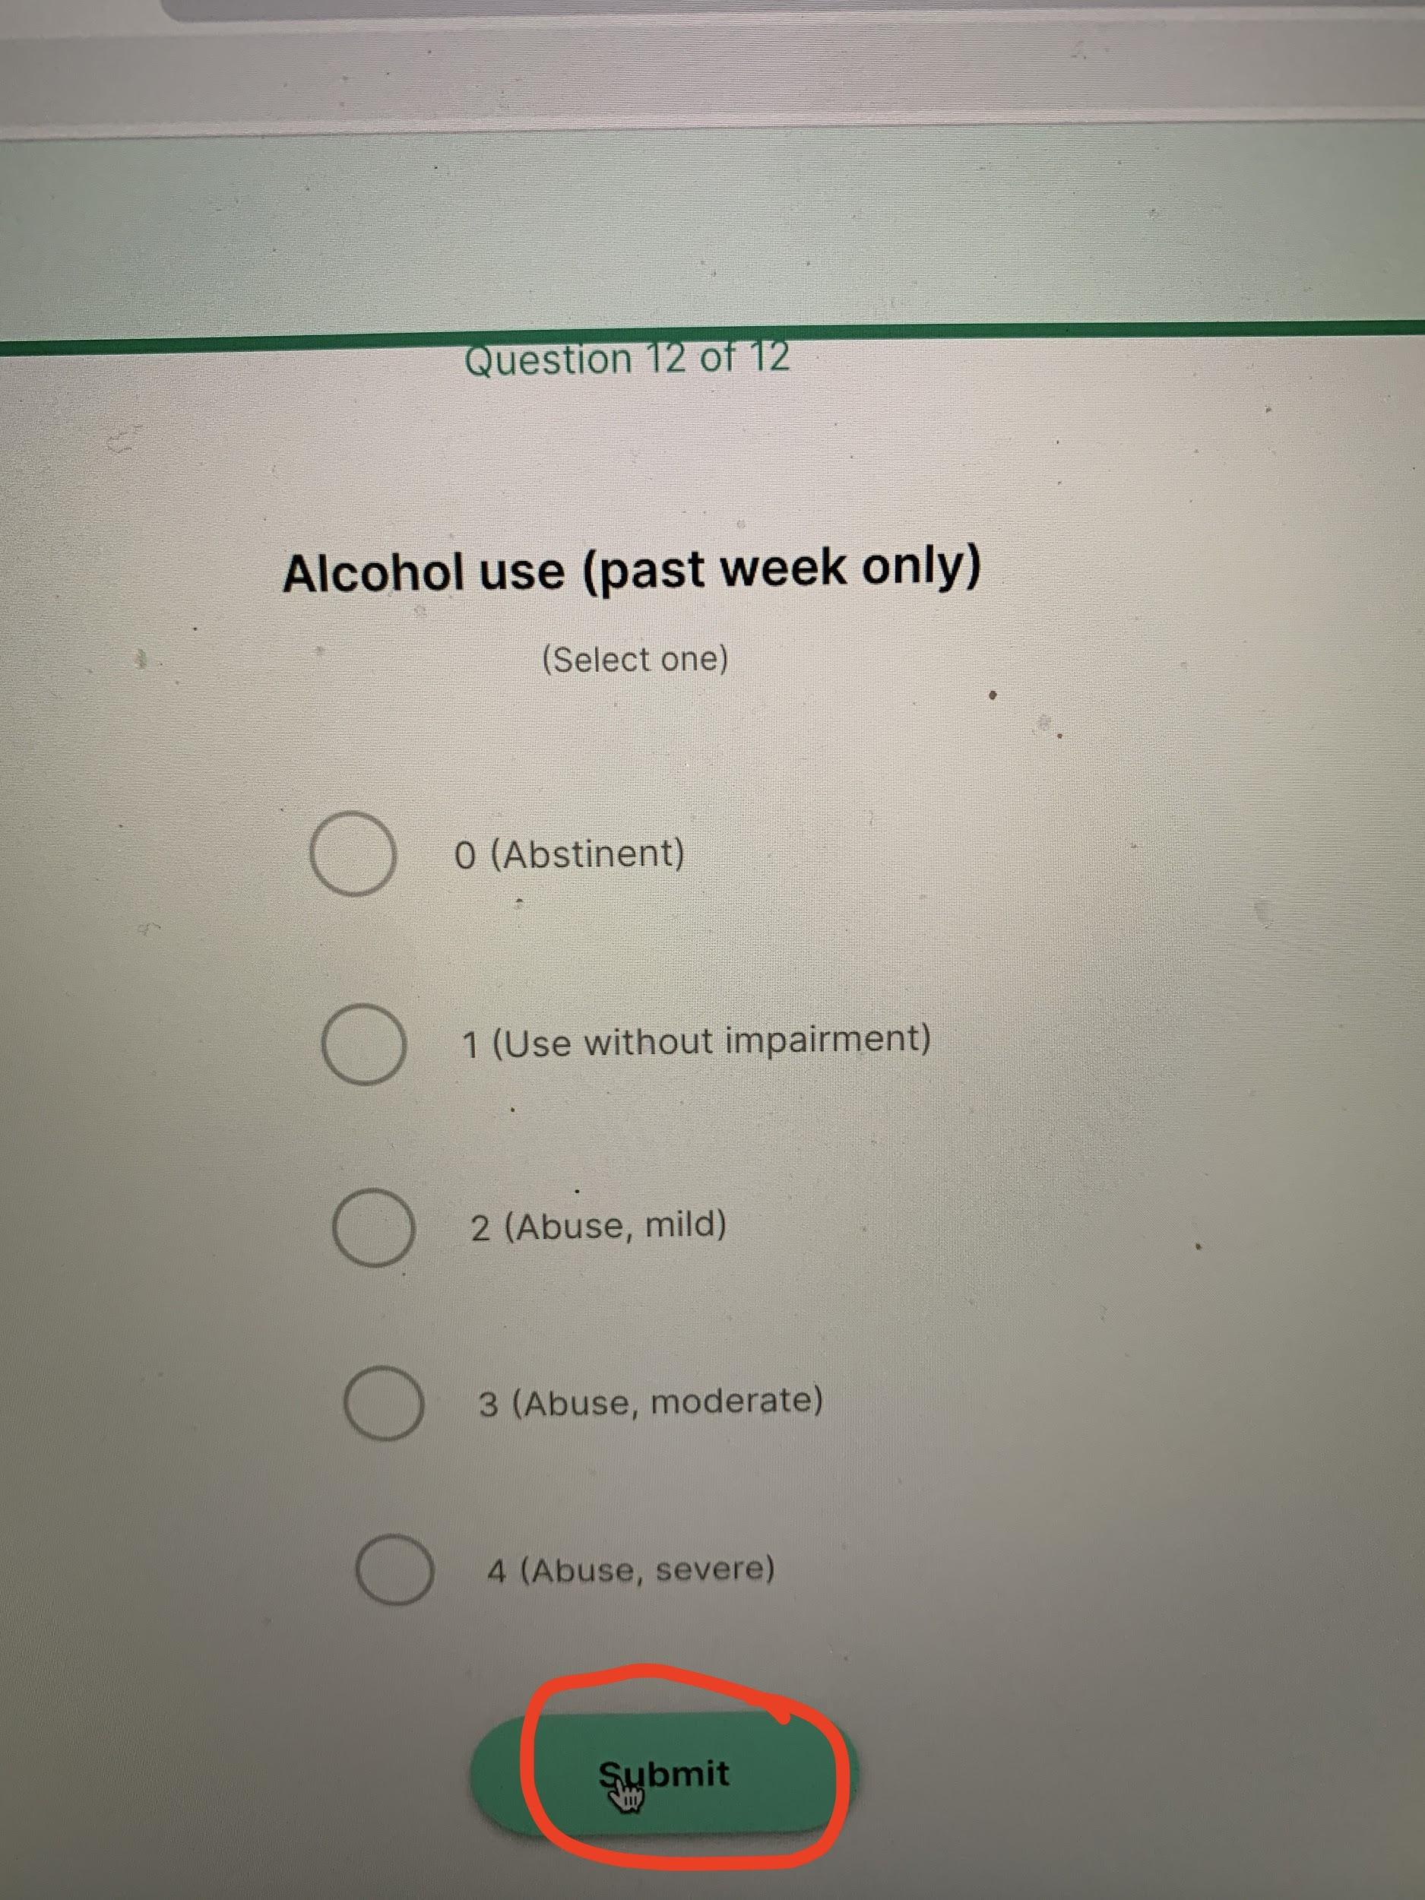

**Thank you for your contributions!**